Blackboard Ally
Course documents that are placed on Blackboard can be altered into accessible formats by using Blackboard Ally.

Visit here for how to use it in video format.
Blackboard Ally | Digital Education Office | University of Bristol
For more videos to show you how click the link below or copy and paste the web address:
Watch Videos | Blackboard Help
https://help.blackboard.com/Ally/Ally_for_LMS/Student/Watch_Videos

Choose the format you need
Your tutor probably has many different pieces of content in your course. Ally creates alternative formats for those content items. You can download the alternative formats anywhere you see Ally's alternative formats download icon. Just choose the version of the original that is best for your needs!
Sign in to your course. Look for the Download Alternative Formats icon and download a format that suits your learning needs.
Don’t stick to just one format! Use as many formats as you want.
Need help choosing? More on alternative formats
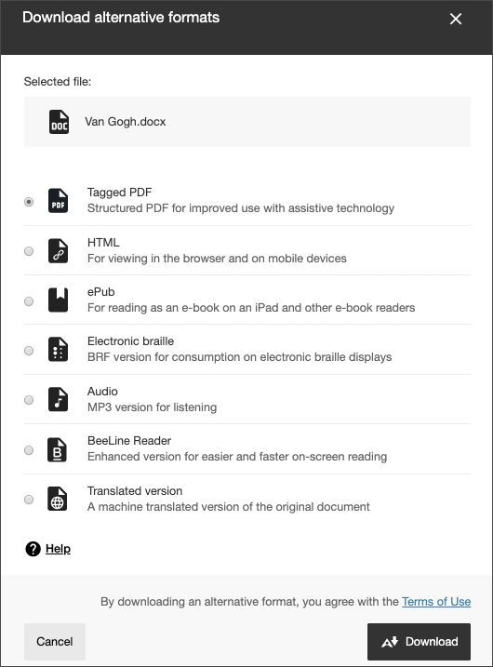

See how the Alternative Format icon looks in your course

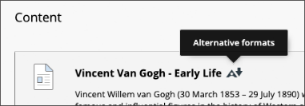
Blackboard Learn Original Course View

Blackboard app
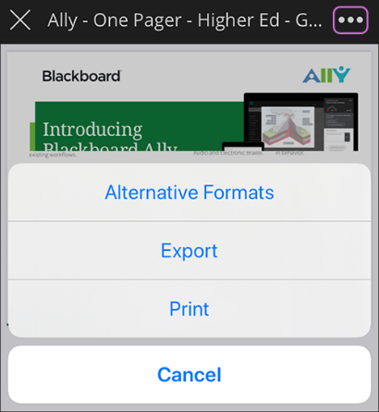

What format is best for me?
